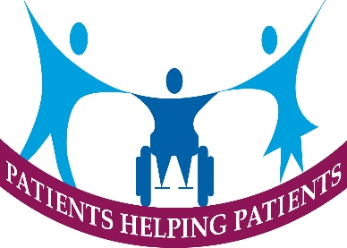 Moorland Medical Centre Patient Participation Group
Notes of Meeting held on Tuesday 9th April 2024
Present: 9 members Apologies from 9 members
NHS App Digital Access
There was a lengthy discussion on how the group can encourage more patients to use the NHS App to access repeat prescriptions, make appointments etc as this will reduce the workload of the Medical Receptionists particularly dealing with routine appointments leaving them freer to handle emergency appointments on the day.
It was agreed that the communication sub group would progress this item and report back.
Did Not Attend (DNA’s)
In the Practice the average percentage of appointments that are lost due to patients not turning up/ failing to cancel is around 2% of appointments i.e. 85 per month.
The group are looking at the detailed analysis along with Practice management to suggest ways in which this amount of DNA’s can be reduced to make these appointments available for other patients to book appointments.
Improved Telephone system
The Integrated Care Board for Staffordshire is promoting to all GP Practices in 2024/25 to enhance their telephone systems to provide more detailed breakdowns of calls to assess how many calls are aborted by patients due to long wait, how quickly calls are answered, how and when queues are excessive etc. It is hoped that this detailed understanding will enable the Practice to organise their staffing more effectively to ensure patients get the best service possible with the resources available. The upgraded system also has the enhanced facility of a call back function for patients to use.
Spring Covid Booster
The Primary care network will be offering this to all patients who qualify. That is patients in Care homes or housebound and all patients over 75 years old. Patients will get a text message if they have a digital phone or they will be alerted by the practice. In Leek the vaccinations will be organised by Leek Health Centre, Fountain Street for all Leek Practices.
Integrated Care Board –Patient Representation
For some time the Group along with the Patient Locality Group for Leek & Biddulph have been concerned that the patient voice is limited and have been trying get this changed. We are pleased that the ICB has set up a PPG network group across the County and we will be represented at the in augural meeting on 8th May by David Jones.

